

“I-SEARCH user interfaces  
for PCs and mobile devices”

D7.3

‘’

Version: 1.0

Last Update: 22/6/2012 12:06:00 20126/P6

Distribution Level: PU (Report), RE (Prototype)

* ***Distribution level***

*PU = Public,*

*RE = Restricted to a group of the specified Consortium,*

*PP = Restricted to other program participants (including Commission Services),*

***CO= Confidential, only for members of the I-SEARCH Consortium (including the Commission Services)***

***The research leading to these results has received funding from the European Community's Seventh Framework***

***Programme (FP7/2007-2013) under grant agreement n° 248296***

fp7.jpg

**The I-SEARCH Project Consortium groups the following organizations:**

|  |  |  |
| --- | --- | --- |
| **Partner Name** | **Short name** | **Country** |
| Centre for Research and Technology Hellas / Informatics and Telematics Institute | CERTH | GR |
| JCP-Consult | JCP | FR |
| Institut National de Recherche en Informatique | INRIA | FR |
| Athens Technology Center | ATC | GR |
| Engineering Ingegneria Informatica S.p.A. | ENG | IT |
| Google Ireland Limited | Google | IR |
| University of Genoa | UNIGE | IT |
| Exalead | EXL | FR |
| Fulda University of Applied Sciences | HSF | DE |
| Accademia Nazionale di Santa Cecilia | ANSC | IT |
| EasternGraphics GmbH | EGR | DE |

**Executive Summary:** In this deliverable, we report on work around the I-SEARCH EU (FP7 ICT STREP) project whose objective is the development of a multimodal search engine. We present the project's objectives, and detail the achieved results, amongst which a Rich Unified Content Description format.

Document Identity

|  |  |
| --- | --- |
| Title: | I-SEARCH user interfaces for PCs and mobile devices |
| Subject: | Description of user interface challenges and solutions for multimodal interaction with different classes of devices |
| Number: |  |
| File name: | WP 7.3 Google.docx |
| Registration Date: | 20 June, 2012 |
| Last Update: | 22 June 2012 |
| Authors: | GOOGLE, HSF, CERTH |

Revision History

|  |  |  |  |  |
| --- | --- | --- | --- | --- |
| No. | Version | Edition | Author(s) | Date |
| 1 | 0.1 | 1 | Thomas Steiner | 20/06/2012 |
| Comments: | Initial release | | |
| 2 |  |  |  |  |
| Comments: |  | | |
| 3 |  |  |  |  |
| Comments: |  | | |
| 4 |  |  |  |  |
| Comments: |  | | |
| 5 |  |  |  |  |
| Comments: |  | | |
| 6 |  |  |  |  |
| Comments: |  | | |
| 7 |  |  |  |  |
| Comments: |  | | |
| 8 |  |  |  |  |
| Comments: |  | | |
| 9 |  |  |  |  |
| Comments: |  | | |

**Table of Content**

1 INTRODUCTION 7

1.1 Motivation 7

1.2 Background 7

1.3 Involved Partners and Deliverable Structure 7

2 PROJECT GOALS 7

3 PROJECT RESULTS 8

3.1 Rich Unified Content Description 8

3.2 Graphical User Interface 8

3.3 Video and Image 9

3.4 Audio and Emotions 9

3.5 3D Objects 10

3.6 Visualization 10

3.7 Orchestration 10

3.8 Content Providers 10

4 SYSTEM DEMONSTRATION 10

5 Use Cases 10

6 Modalities Across Devices 11

7 RELATED WORK 12

8 FUTURE WORK AND CONCLUSION 12

9 References 12

**List of Figures**

Figure 1: I-SEARCH graphical user interface. 8

**List of Abbreviations and acronyms**

(in alphabetic order)

|  |  |
| --- | --- |
| **Abbreviation** | **Explanation** |
| API | Application Programmable Interface |
| CoFind | Collaborative Search |
| GUI | Graphical User Interface |
| HTML5 | Hypertext Mark-up Language 5 |
| pTag | Personalized Tagging Service |
| RUCoD | Rich Unified Content Description |
| UI | User Interface |
| UIIFace | Unified Interaction Interface |
| W3C | World Wide Web Consortium |
| XML | Extensible Mark-up Language |
| XMI | XML Metadata Interchange |
| SDK | Software Development Kit |
| URL | Unified Resource Identifier |
| CO | Content Object |
| DOM | Document Object Model |
| JSGF | Java Speech Grammar Format |
| REST | REpresentational State Transfer |

# INTRODUCTION

## Motivation

Since the beginning of the age of Web search engines in 1990, the search process is associated with a text input field. From the first search engine, Archie [6], to state-of-the-art search engines like WolframAlpha [1](eut13-steiner2.html#fn1x0) , this fundamental input paradigm has not changed. In a certain sense the search process has been revolutionized on mobile devices through the addition of voice input support like Apple’s Siri [1] for iOS, Google’s Voice Actions [2] for Android, and through Voice Search [3] for desktop computers. Support for the human voice as an input modality is mainly driven by shortcomings of (mobile) keyboards. One modality, text, is simply replaced by another, voice. However, what is still missing is a truly multimodal search engine. If the searched-for item is slow, sad, minor scale piano music, the best input modalities might be to just upload a short sample (“audio”) and an unhappy smiley face or a sad body expressive gesture (“emotion”). When searching for the sound of Times Square, New York, the best input modalities might be the coordinates (“geolocation”) of Times Square and a photo of a yellow cab (“image”). The outlined search scenarios are of very different nature, and even for human beings it is not easy to find the correct answer, let alone that such answer exists for each scenario. With I-SEARCH, we thus strive for a paradigm shift; away from textual keyword search, towards a more explorative multimodality-driven search experience.

## Background

It is evident that for the outlined scenarios to work, a significant investment in describing the underlying media items is necessary. Therefore, in [5], we have first introduced the concept of so-called content objects, and second, a description format named Rich Unified Content Description (RUCoD). Content objects are rich media presentations, enclosing different types of media, along with real-world information and user-related information. RUCoD provides a uniform descriptor for all types of content objects, irrespective of the underlying media and accompanying information. Due to the enormous processing costs for the description of content objects, our approach currently is not yet applicable on Web scale. We target “Company Wide Intraweb” scale rather than World Wide Web scale environments, which, however, we make accessible in a multimodal way from the World Wide Web.

## Involved Partners and Deliverable Structure

The involved partners are CERTH/ITI (Greece), JCP-Consult (France), INRIA Rocquencourt (France), ATC (Greece), Engineering Ingegneria Informatica S.p.A. (Italy), Google (Ireland), University of Genoa (Italy), Exalead (France), University of Applied Sciences Fulda (Germany), Accademia Nazionale di Santa Cecilia (Italy), and EasternGraphics (Germany). In this deliverable, we give an overview on the I-SEARCH project so far. In Section 2, we outline the general objectives of I-SEARCH. Section 3 highlights significant achievements. We describe the details of our system in Section 4. Relevant related work is shown in Section 5. We conclude with an outlook on future work and perspectives of this EU project.

# PROJECT GOALS

With the I-SEARCH project, we aim for the creation of a multimodal search engine that allows for both multimodal in- and output. Supported input modalities are audio, video, rhythm, image, 3D object, sketch, emotion, social signals, geolocation, and text. Each modality can be combined with all other modalities. The graphical user interface (GUI) of I-SEARCH is not tied to a specific class of devices, but rather dynamically adapts to the particular device constraints like varying screen sizes of desktop and mobile devices like cell phones and tablets. An important part of I-SEARCH is a Rich Unified Content Description (RUCoD) format that consists of a multi-layered structure that describes low and high level features of content and hence allows this content to be searched in a consistent way by querying RUCoD features. Through the increasing availability of location-aware capture devices such as digital cameras with GPS receivers, produced content contains exploitable real-world information that form part of RUCoD descriptions.

# PROJECT RESULTS

## Rich Unified Content Description

In order to describe content objects consistently, a Rich Unified Content Description (RUCoD) format was developed. The format is specified in form of XML schemas and available on the project website[2](eut13-steiner3.html#fn2x0) . The description format has been introduced in full detail in [5], Listing 1 illustrates RUCoD with an example.

## Graphical User Interface

The I-SEARCH graphical user interface (GUI) is implemented with the objective of sharing one common code base for all possible input devices (Subfigure 1b shows mobile devices of different screen sizes and operating systems). It uses a JavaScript-based component called UIIFace [7], which enables the user to interact with I-SEARCH via a wide range of modern input modalities like touch, gestures, or speech. The GUI also provides a WebSocket-based collaborative search tool called CoFind [7] that enables users to search collaboratively via a shared results basket, and to exchange messages throughout the search process. A third component called pTag [7] produces personalized tag recommendations to create, tag, and filter search queries and results.

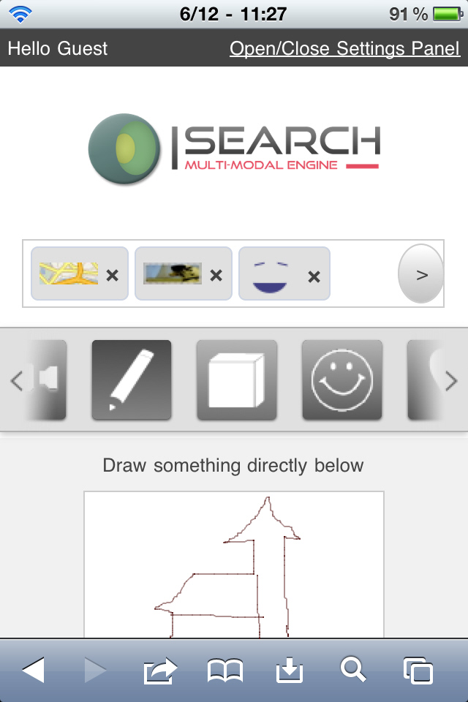  
(a) Multimodal query consisting of geolocation, video, emotion, and sketch (in progress).  
 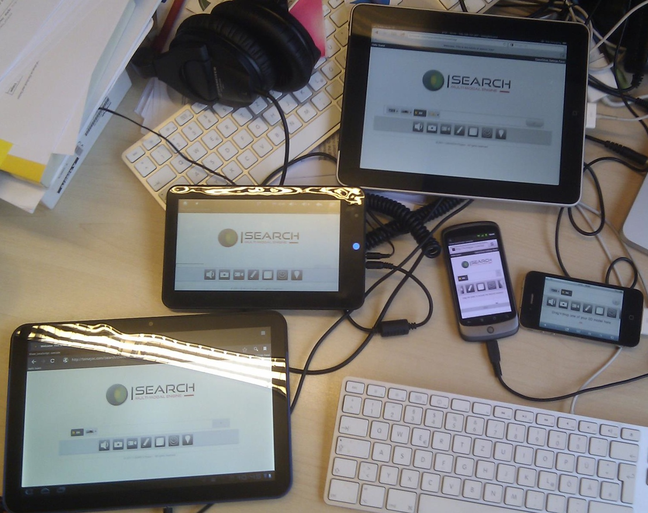  
(b) Running on some mobile devices with different screen sizes and operating systems. 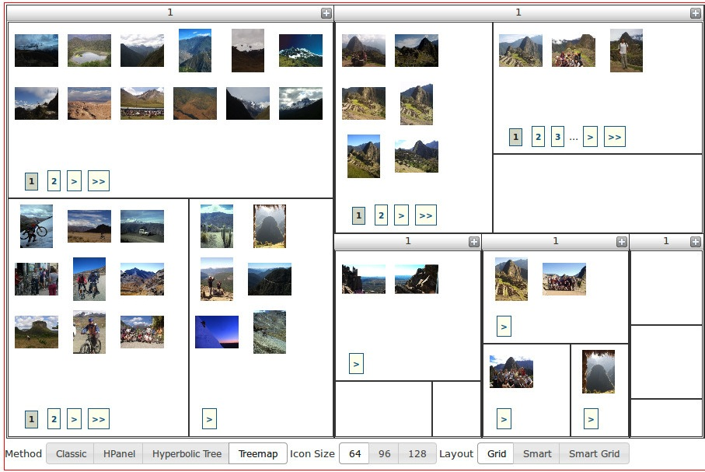  
(c) Treemap results visualization showing different clusters of images. Figure 1: I-SEARCH graphical user interface.

Figure 1: I-SEARCH graphical user interface.

## Video and Image

The video mining component produces a video summary as a set of recurrent image patches to give a visual representation of the video to the user. These patches can be used to refine search and/or to navigate more easily in videos or images. For this purpose, we use a technique of Letessier et al. [12] consisting of a weighted and adaptive sampling strategy aiming to select the most relevant query regions from a set of images. The images are the video key frames and a new clustering method is introduced that returns a set of suggested object-based visual queries. The image search component performs approximate vector search on either local or global image descriptors to speed up response time on large scale databases.

<RUCoD>   
  <Header>   
    <ContentObjectType>   
      Multimedia Collection   
    </ContentObjectType>   
    <ContentObjectName xml:lang=~en-US~>   
      AM General Hummer   
    </ContentObjectName>   
    <ContentObjectCreationInformation>   
      <Creator>   
        <Name>CoFetch Script</Name>   
      </Creator>   
    </ContentObjectCreationInformation>   
    <Tags>   
      <MetaTag name=~UserTag~ type=~xsd:string~>   
        Hummer   
      </MetaTag>   
    </Tags>   
    <ContentObjectTypes>   
      <MultimediaContent type=~Object3d~>   
        <FreeText>Not Mirza’s model.</FreeText>   
        <MediaName>2001 Hummer H1</MediaName>   
        <MetaTag name=~UserTag~ type=~xsd:string~>   
          Hummer   
        </MetaTag>   
        <MediaLocator>   
          <MediaUri>   
            http://sketchup.google.com/[...]   
          </MediaUri>   
          <MediaPreview>   
            http://sketchup.google.com/[...]   
          </MediaPreview>   
        </MediaLocator>   
        <MediaCreationInformation>   
          <Author>   
            <Name>ZXT</Name>   
          </Author>   
          <Licensing>   
            Google 3D Warehouse License   
          </Licensing>   
        </MediaCreationInformation>   
        <Size>1840928</Size>   
      </MultimediaContent>   
      <RealWorldInfo>   
        <MetadataUri filetype=~rwml~>   
          AM_General_Hummer.rwml   
        </MetadataUri>   
      </RealWorldInfo>   
    </ContentObjectTypes>   
  </Header>   
</RUCoD>

Listing 1: Sample RUCoD snippet (namespace declarations and some details removed for legibility).

## Audio and Emotions

I-SEARCH includes the extraction of expressive and emotional information conveyed by a user to build a query, and the possibility to build queries resulting from a social verbal or non-verbal interaction among a group of users. The I-SEARCH platform includes algorithms for the analysis of non-verbal expressive and emotional behavior expressed by full body gestures, for the analysis of the social behavior in a group of users (e.g., synchronization, leadership), and methods to extract real-world data.

## 3D Objects

The 3D object descriptor extractor is the component for extracting low level features from 3D objects and is invoked during the content analytics process. More specifically, it takes as input a 3D object and returns a fragment of low level descriptors fully compliant with the RUCoD format.

## Visualization

I-SEARCH uses sophisticated information visualization techniques that support not only querying information, but also browsing techniques for effectively locating relevant information. The presentation of search results is guided by analytic processes such as clustering and dimensionality reduction that are performed after the retrieval process and intend to discover relations among the data. This additional information is subsequently used to present the results to the user by means of modern information visualization techniques such as treemaps, an example of such can be seen in Subfigure Subsection 1c. The visualization interface is able to seamlessly mix results from multiple modalities

## Orchestration

Content enrichment is an articulated process requiring the orchestration of different workflow fragments. In this context, a so-called Content Analytics Controller was developed, which is the component in charge of orchestrating the content analytics process for content object enrichment via low level description extraction. It relies on content object media and related info, handled by a RUCoD authoring tool.

## Content Providers

The first content provider in the I-SEARCH projects holds an important Italian ethnomusicology archive. The partner makes available all of its digital content to the project as well as its expertise for the development of requirements and use cases related to music. The second content provider is a software vendor for the furniture industry with a big catalogue of individually customizable pieces of furniture. Both partners are also actively involved in user testing and the overall content collection effort for the project via deployed Web services that return their results in the RUCoD format.

# SYSTEM DEMONSTRATION

With I-SEARCH being in its second year, there is now some basic functionality in place. We maintain a bleeding-edge demonstration server[3](eut13-steiner4.html#fn3x0) , and have recorded a screencast[4](eut13-steiner5.html#fn4x0) that shows some of the interaction patterns. The GUI runs on both mobile and desktop devices, and adapts dynamically to the available screen real estate, which, especially on mobile devices, can be a challenge. Supported input modalities at this point are audio, video, rhythm, image, 3D object, sketch, emotion, geolocation, and text. For emotion, an innovative emotion slider open source solution [13] was adapted to our needs. The GUI supports drag and drop user interactions and we aim for supporting low level device access for audio and video uploads. For 3D objects, we support Web GL powered 3D views of models. Text can be entered via speech input based on the WAMI toolkit [9], or via keyboard. First results can be seen upon submitting a query, and the visualization component allows to switch back and forth between different views.

# Use Cases

In order to give the reader an idea of intended I-SEARCH usage and to motivate multimodality, we introduce three use cases and involved modalities as defined by the project. .

##### *UC1: Music Expert (Desktop, Mobile)*

A music expert with access to a big music archive does research on the influence of traditional folk music on today’s popular music. She inputs a rhythm to the I-SEARCH system in order to search the archive for similar rhythm patterns. She refines her query by adding geolocation to limit results to a certain region and by uploading a disco image. .

##### *UC2: Interior Designer (Desktop)*

An interior designer wants to give her client a realistic idea of office chairs. She uploads a 3D model of a chair that almost matches her client’s expectations to the I-SEARCH system, together with an image of the upholstery. She refines with a hand-drawn sketch of the chair’s shape. .

##### *UC3: World Traveler (Mobile)*

A traveler uses her cell phone with the I-SEARCH app to create media content with associated geolocation data like videos and images of the sights she visits to retrieve related content of other travelers, text descriptions, and 3D models that she wants to use to map her trip on a virtual globe. .

# Modalities Across Devices

In this Section, we focus on input modalities across mobile and desktop device classes and their support in I-SEARCH.

Audio, Image, Video We describe audio, image, and video modalities together, as they share the same interaction patterns. On desktop devices, audios, images, or videos can be uploaded from the user’s hard disk via a file upload dialog or via drag ’n’ drop. On some mobile devices (e.g., iOS devices) file uploading is prohibited, which is why in the longterm, as support advances, we aim at using the getUserMedia API [15]. At time of writing, access to getUserMedia is available in developer preview builds of several browsers. The fallback solution is a Flash uploader.

Rhythm On desktop devices, we support entering a rhythm by key presses or mouse tapping, whereas additionally on mobile devices a rhythm can also be captured via the device orientation API [14] by tilting the device rhythmically.

3D Object We support 3D objects on mobile and desktop via the COLLADA 3D asset exchange schema [18]. 3D objects can be inserted via a file upload dialog or drag ’n’ drop.

Text On mobile and desktop, text can be entered using the keyboard or using the speech input API [21].

Emotion In order to accompany a query by basic emotional feedback, we have adapted an open-source emotion input solution [13] for mobile and desktop that transfers the slider user interface pattern to emotions from sad to happy.

Geolocation For retrieving and tracking a user’s physical location, we use the HTML5 geolocation API [20], which is available in Web browsers on mobile and desktop devices.

Sketch Hand-drawn sketches can be created on mobile and desktop devices alike using a simple touch-based HTML5 canvas [17] sketch editor. .

# RELATED WORK

Multimodal search can be used in two senses; (i), in the sense of multimodal result output based on unimodal query input, and (ii), in the sense of multimodal result output and multimodal query input. We follow the second definition, i.e., require the query input interface to allow for multimodality.

An interesting multimodal search engine was developed in the scope of the PHAROS project [4]. With the initial query being keyword-based, content-based or a combination of these, the search engine allows for refinement in form of facets, like location, that can be considered modalities. I-SEARCH develops this concept one step further by supporting multimodality from the beginning. In [8], Rahn Frederick discusses the importance of multimodality in search-driven on-device portals, i.e., handset-resident mobile applications, often preloaded, that enhance the discovery and consumption of endorsed mobile content, services, and applications. Consumers can navigate on-device portals by searching with text, voice, and camera images. Rahn Frederick’s article is relevant, as it is specifically focused on mobile devices, albeit the scope of I-SEARCH is broader in the sense of also covering desktop devices. In a W3C Note [11], Larson et al. describe a multimodal interaction framework, and identify the major components for multimodal systems. The multimodal interaction framework is not an architecture per se, but rather a level of abstraction above an architecture and identifies the markup languages used to describe information required by components and for data flows among components. With Mudra [10], Hoste et al. present a unified multimodal interaction framework supporting the integrated processing of low level data streams as well as high level semantic inferences. Their architecture is designed to support a growing set of input modalities as well as to enable the integration of existing or novel multimodal fusion engines. Input fusion engines combine and interpret data from multiple input modalities in a parallel or sequential way. I-SEARCH is a search engine that captures modalities sequentially, however, processes them in parallel.

# FUTURE WORK AND CONCLUSION

The efforts in the coming months will focus on integrating the different components. Interesting challenges lie ahead with the presentation of results and result refinements. In order to test the search engine, a set of use cases has been compiled that covers a broad range of modalities, and combinations of such. We will evaluate those use cases and test the results in user studies involving customers of the industry partners in the project.

In this deliverable, we have introduced and motivated the I-SEARCH project and have shown the involved components from the different project partners. We have then presented first results, provided a system demonstration, and positioned our project in relation to related work in the field. The coming months will be fully dedicated to the integration efforts of the partners’ components and we are optimistic to successfully evaluate the set of use cases in a future deliverable.

# References

[1] Apple iPhone 4S – Ask Siri to help you get things done. Avail. at http://www.apple.com/iphone/features/siri.html.

[2] Google Voice Actions for Android, 2011. Avail. at http://www.google.com/mobile/voice-actions/.

[3] Google Voice Search – Inside Google Search, 2011. Avail. at http://www.google.com/insidesearch/voicesearch.html.

[4] A. Bozzon, M. Brambilla, Fraternali, et al. PHAROS: an audiovisual search platform. In Proceedings of the 32nd Int. ACM SIGIR Conf. on Research and Development in Information Retrieval, SIGIR ’09, pages 841–841, New York, NY, USA, 2009. ACM.

[5] P. Daras, A. Axenopoulos, V. Darlagiannis, et al. Introducing a Unified Framework for Content Object Description. Int. Journal of Multimedia Intelligence and Security (IJMIS). Accepted for publication. Avail. at http://www.lsi.upc.edu/~tsteiner/papers/ 2010/rucod-specification-ijmis2010.pdf, 2010.

[6] A. Emtage, B. Heelan, and J. P. Deutsch. Archie, 1990. Avail. at http://archie.icm.edu.pl/archie-adv_eng.html.

[7] J. Etzold, A. Brousseau, P. Grimm, and T. Steiner. Context-aware Querying for Multimodal Search Engines. In 18th Int. Conf. on MultiMedia Modeling (MMM 2012), Klagenfurt, Austria, January 4-6, 2012. http://www.lsi.upc.edu/ tsteiner/papers/2012/context- aware-querying-mmm2012.pdf.

[8] G. R. Frederick. Just Say “Britney Spears”: Multi-Modal Search and On-Device Portals, Mar. 2009. Avail. at http://java.sun.com/developer/ technicalArticles/javame/odp/multimodal-odp/.

[9] A. Gruenstein, I. McGraw, and I. Badr. The WAMI Toolkit for Developing, Deploying, and Evaluating Web-accessible Multimodal Interfaces. In ICMI, pages 141–148, 2008.

[10] L. Hoste, B. Dumas, and B. Signer. Mudra: A Unified Multimodal Interaction Framework. 2011. Avail. at http://wise.vub.ac.be/sites/default/files/ publications/ICMI2011.pdf.

[11] D. R. James A. Larson, T.V. Raman. W3C Multimodal Interaction Framework. Technical report, May 2003. Avail. at http://www.w3.org/TR/mmi-framework/.

[12] P. Letessier, O. Buisson, and A. Joly. Consistent visual words mining with adaptive sampling. In ICMR, Trento, Italy, 2011.

[13] G. Little. Smiley Slider. Avail. at http://glittle.org/smiley-slider/.

[14] S. Block and A. Popescu. DeviceOrientation Event Specification – Editor’s Draft 12 July 2011. http://dev.w3.org/geo/api/ spec-source-orientation.html.

[15] D. C. Burnett and A. Narayanan. getUserMedia: Getting access to local devices that can generate multimedia streams. http://dev.w3.org/2011/ webrtc/editor/getusermedia.html.

[16] S. Champeon. Progressive Enhancement and the Future of Web Design. http://www.hesketh.com/ thought-leadership/our-publications/ progressive-enhancement-and-future-web-design.

[17] I. Hickson. HTML5 – The canvas element. http://www.w3.org/TR/html5/the-canvas-element.html#the-canvas-element.

[18] Khronos Group. COLLADA - 3D Asset Exchange Schema. http://www.collada.org/.

[19] H. Lie, T. C ̧ elik, D. Glazman, et al. Media Queries – W3C Candidate Recommendation 27 July 2010. http://www.w3.org/TR/css3-mediaqueries/.

[20] A. Popescu. Geolocation API Specification, 2010. http://dev.w3.org/geo/api/spec-source.html.

[21] S. Sampath and B. Bringert. Speech Input API Specification – Editor’s Draft 18 October 2010. http://www.w3.org/2005/Incubator/htmlspeech/ 2010/10/google-api-draft.html.

[22] T. Steiner, L. Sutton, S. Spiller, et al. I-SEARCH – A Multimodal Search Engine based on Rich Unified Content Description (RUCoD). European Projects Track at the 21st Int. World Wide Web Conf., 2012.

---End of Document ---